Suffolk Open Studios 2021

Updating Member Website Details

We have made a number of significant changes for 2021 to enable us to have the relevant information for our exciting new App. This means that there are additional (and changed) fields that will need completing on the website after you renew your membership.
In addition to this, we have been surprised by a last-minute major update to the plugin that manages the member applications and listings – giving us less than 2 weeks to prepare for the renewal.
This means that it is possible you will come across errors and issues that we have not been able to foresee. If so please email Marian at openstudiossuffolk@gmail.com
The major change is that there are now 3 pages that need to be navigated, to complete any updates (as was the case a few years ago).
We are aware that you may not have made a decision about opening yet as the pandemic may play a part in that decision making process, therefore, the information you enter can be revised until 28th February 2021.
This is what you need to do to update your listing:
First you need to log in to your account via the website on the right hand side of the home page – shown in the image below indicated in red (if you are updating after your renewal you may already be logged in).
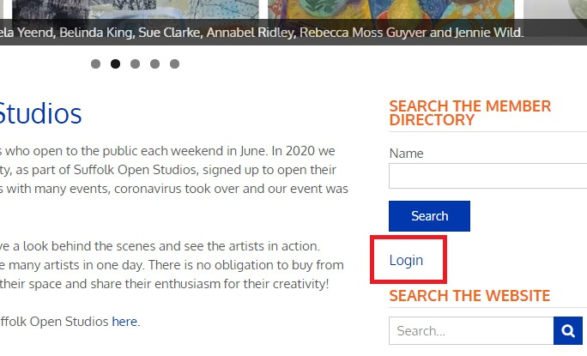

Once you are logged in you will see this instead (shown in the image below indicated in red):
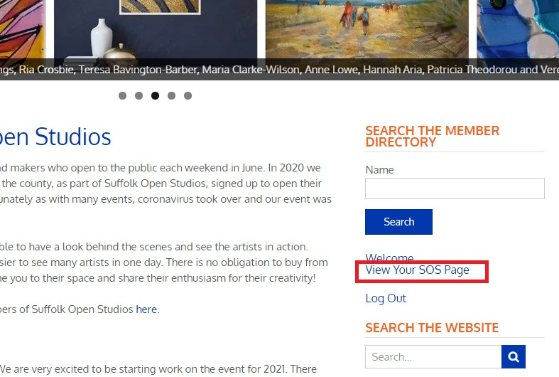
Click on the link “View your SOS page” which will take you to a page showing the listing that you have created with that user profile.
Click on the “EDIT” button shown on your listing at the bottom right and you will see the following page:
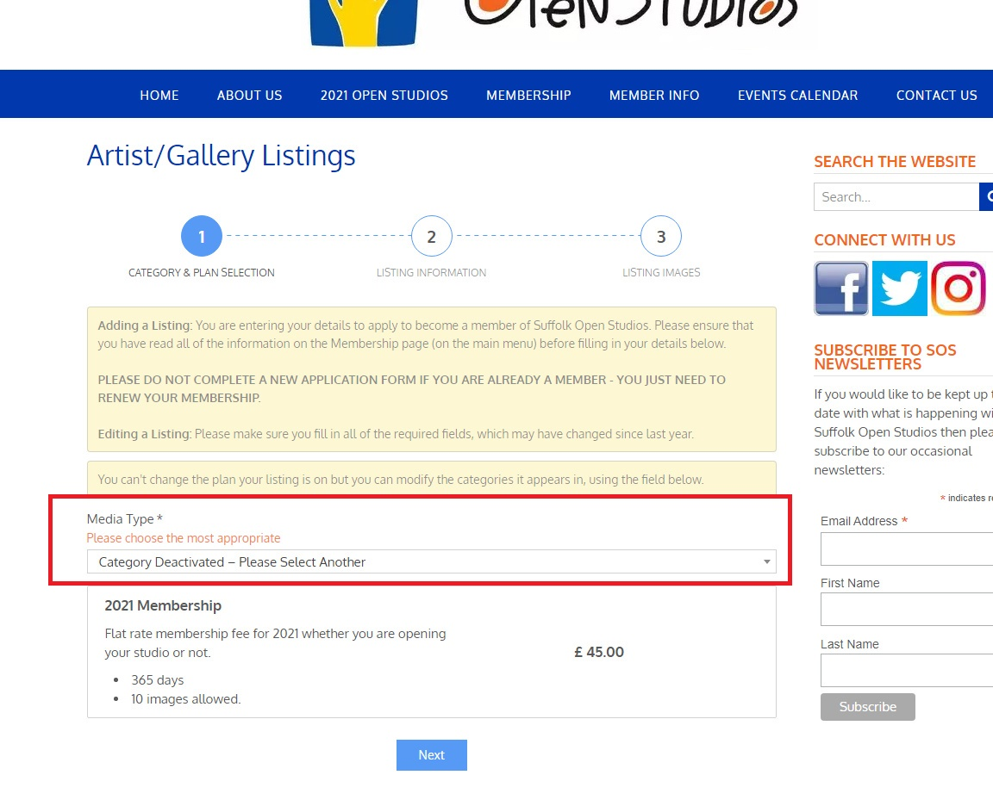
As we have had to make major changes to the system we need you to update this field – it has changed from being type of membership (i.e. associate/full/gallery) to media type – so please choose the most appropriate one.
If you really feel your media type is not represented here then choose ‘other’ and email us if you feel that it should be added to the list (it will likely only be added if there would be multiple members choosing this).

Click on “NEXT” button and you will see the following page (Page 2):
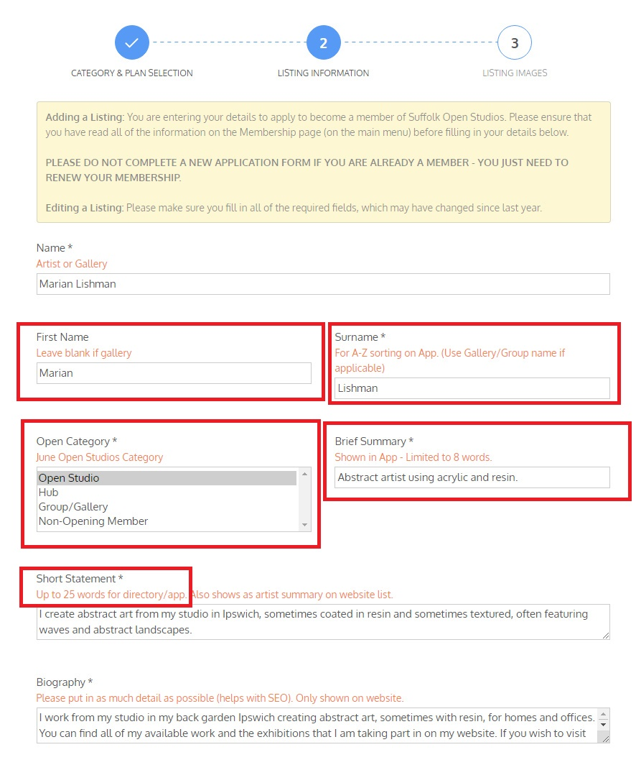
The fields surrounded in red above are the new fields – we need First Name and Surname to sort artists on the App. If you are a gallery or charitable group, then please leave first name blank and fill in the Surname field with the gallery or group name (same as the ‘Name’ field).
Open category is a new field – please choose any option except for Hub – if you are opening in a hub then we will use this option at a later date.

Brief summary and Short Statement fields will be used in the App. An example is below shown with red boxes around them (from the Cambridge Open Studios App):
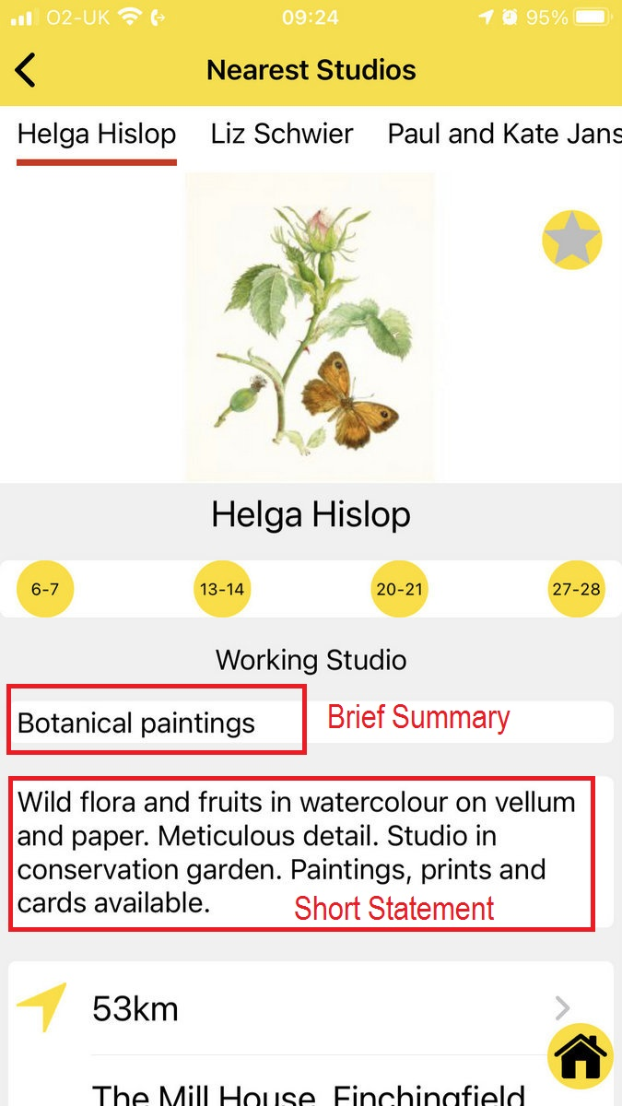
Note that the word count on short statement was not previously restricted (and was specified as 100 words) so you will probably have to reduce what you have in here. This also shows as your description on the website when viewing the list of artists.

The middle of page 2 looks like this:
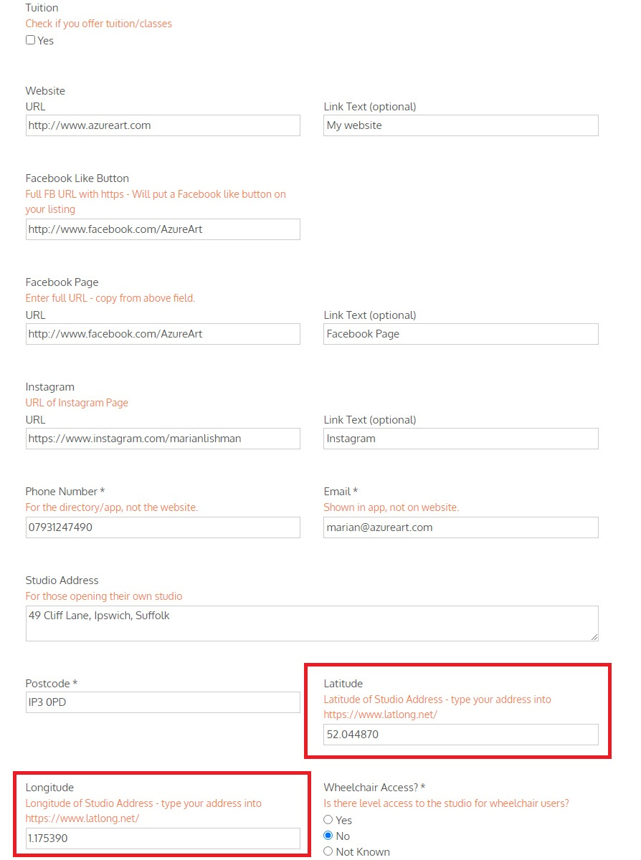
The main new fields here are Latitude and Longitude of your studio address. If you can enter this information, then this will be really helpful as it pinpoints your studio on the map on the App so that people get accurate directions. You can find this data here https://www.latlong.net
If you are not able to do this then we will do a data check before sending it to the app developers and a member of the committee will go through and update any missing information – however, we would appreciate it if each member can do their own if possible to reduce the workload of the committee.

The bottom of page 2 looks like this:
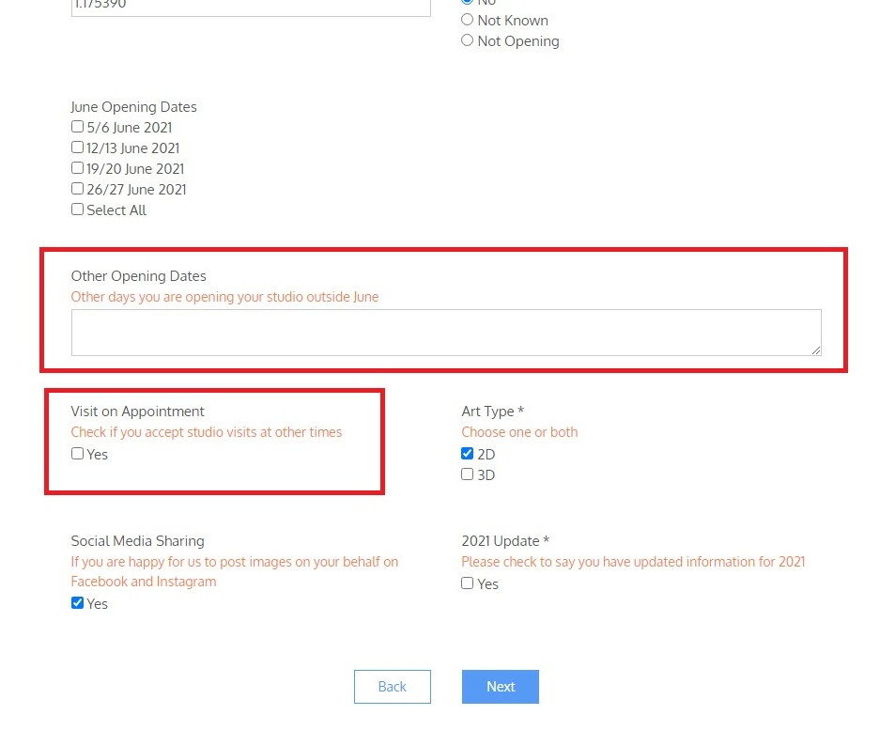
We are aiming to see where we can incorporate extra open studios dates that you might have and also whether you are open to view by appointment. Please complete these if you can, or leave blank if you currently do not offer this. Once we have more information we will contact all members to inform them.
Ensure you have completed all the fields, including the “2021 Update”.
Then you click on “NEXT” it will take you to the 3rd page with your images.
You can add new images if you have space (don’t forget to keep within the parameters of the image sizes before trying to load an image). Images must be less than 1Mb AND be less than 1500 pixels wide and high. Please check images before trying to upload them.
You can resize images using an online tool if you do not have a program that will do it, for example this website:
https://resizeimage.net/
If you already have 10 images and want to change some, you can find the delete button when you hover over an image.
Only when you click on ‘Save Changes’ will you save all of the data that you have entered on all 3 pages.
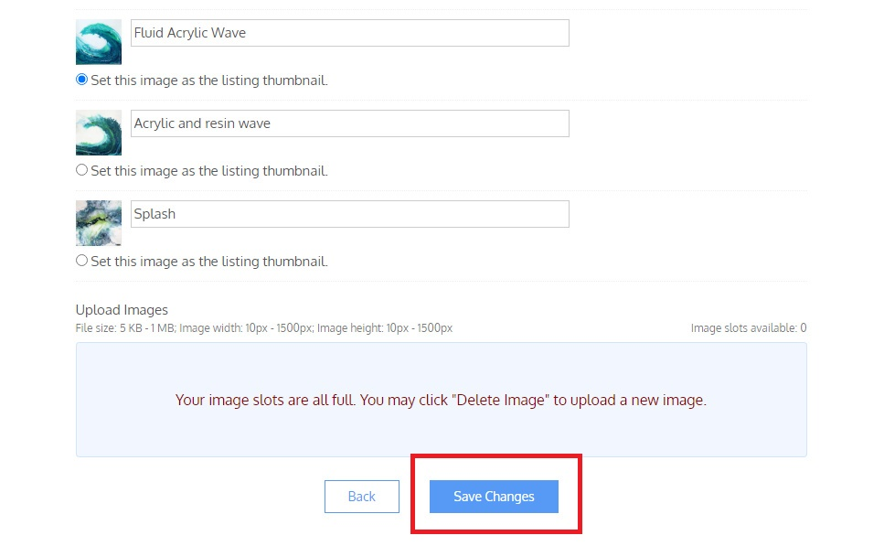

Hub/Studio Combinations

If you are opening at both your studio and a hub:
If you are opening at both then please just include your studio details and address on your own profile (plus dates you are opening at your studio) and select ‘Open Studio’ under the ‘Open Category’ field. Hub details will be added separately.

Hub Only
If you are only opening at a hub, for the time being please select ‘Non-Opening member’ from Open Category. Only enter a studio address if you are open for appointments or open at other times of the year at your own studio. We may change these details as we develop the App to ensure it provides the correct information.

Non-Opening Members
If you are not opening or do not have a studio, then it is up to you if you show an address on your profile or not. We do need to capture your postcode though to know where our members are in terms of distributing leaflets etc.

