Suffolk Open Studios 2021

Updating Member Website Details

In 2021 we made a number of significant changes in your listing details to enable us to have the relevant information for our new App. We have also modified some of the information needed going into 2022 to enable us to have the right information for the App and the printed directory. This means that after you renew, you need to go into your listing and check all of the details, plus add the extra information needed for 2022.
This year the deadline to update your information is 5th February 2022. This gives us enough time to liaise with the printers to get the directory ready for printing by the end of March and distribution by members in April.
This is what you need to do to update your listing:
First you need to log in to your account via the website. You can find the login link in the yellow footer as shown below:
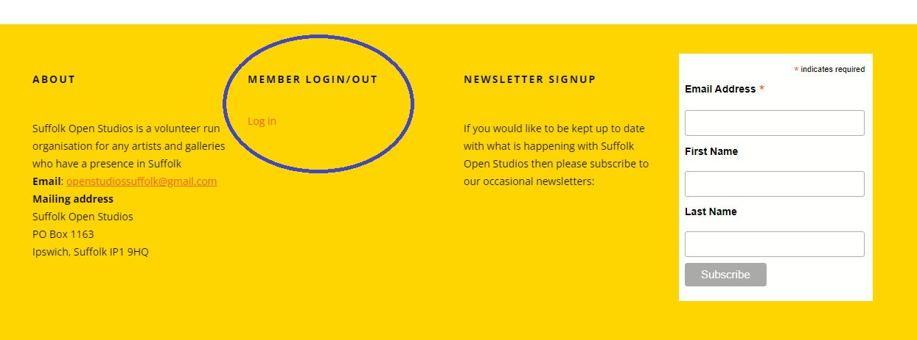

You then need to navigate to the members page as follows:
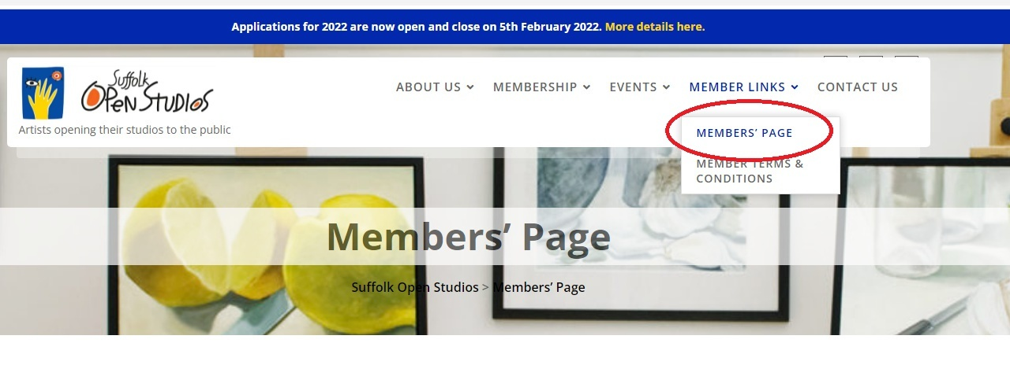

Here you should see your own listing.
Click on the “EDIT” button shown on your listing at the bottom right and you will see the following page:
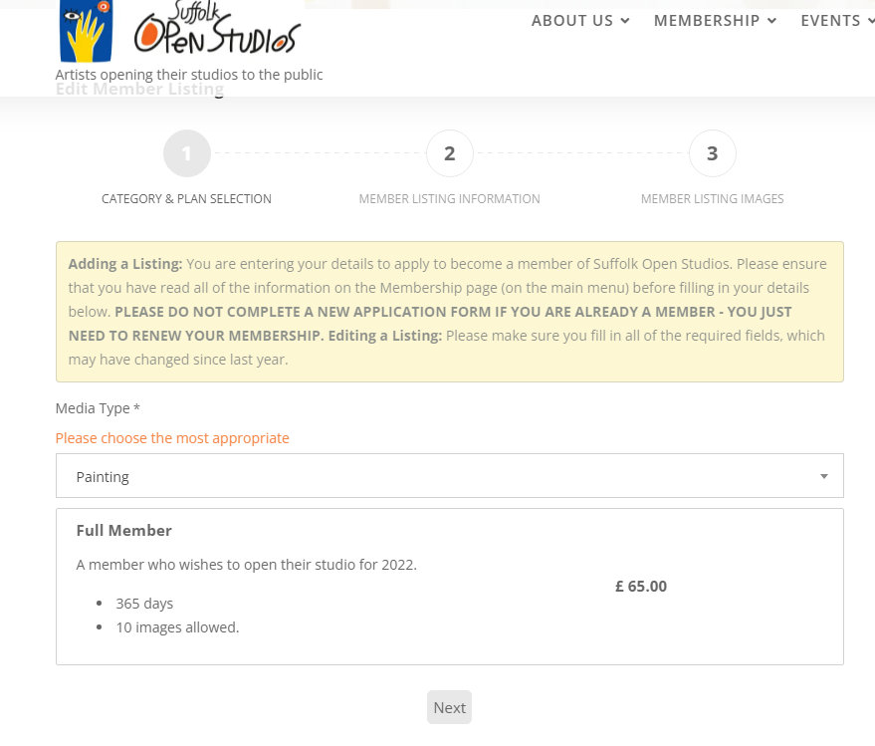
Here you can change your media type if you need to but otherwise just click on ‘NEXT’ to take you to the main page of details.

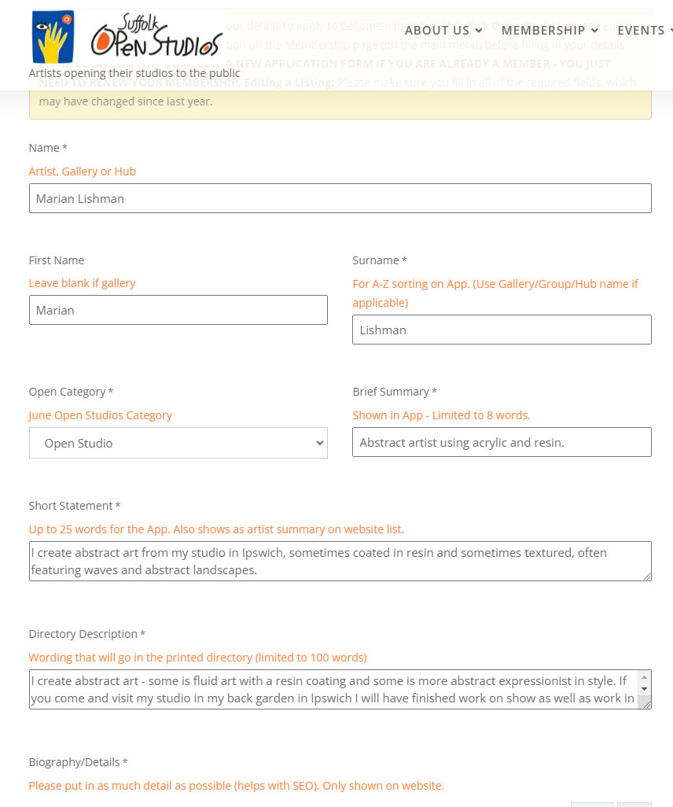
Most fields are similar to last year but as we are now having a directory and the App we need multiple fields with the correct number of words in to fit in the various fields!
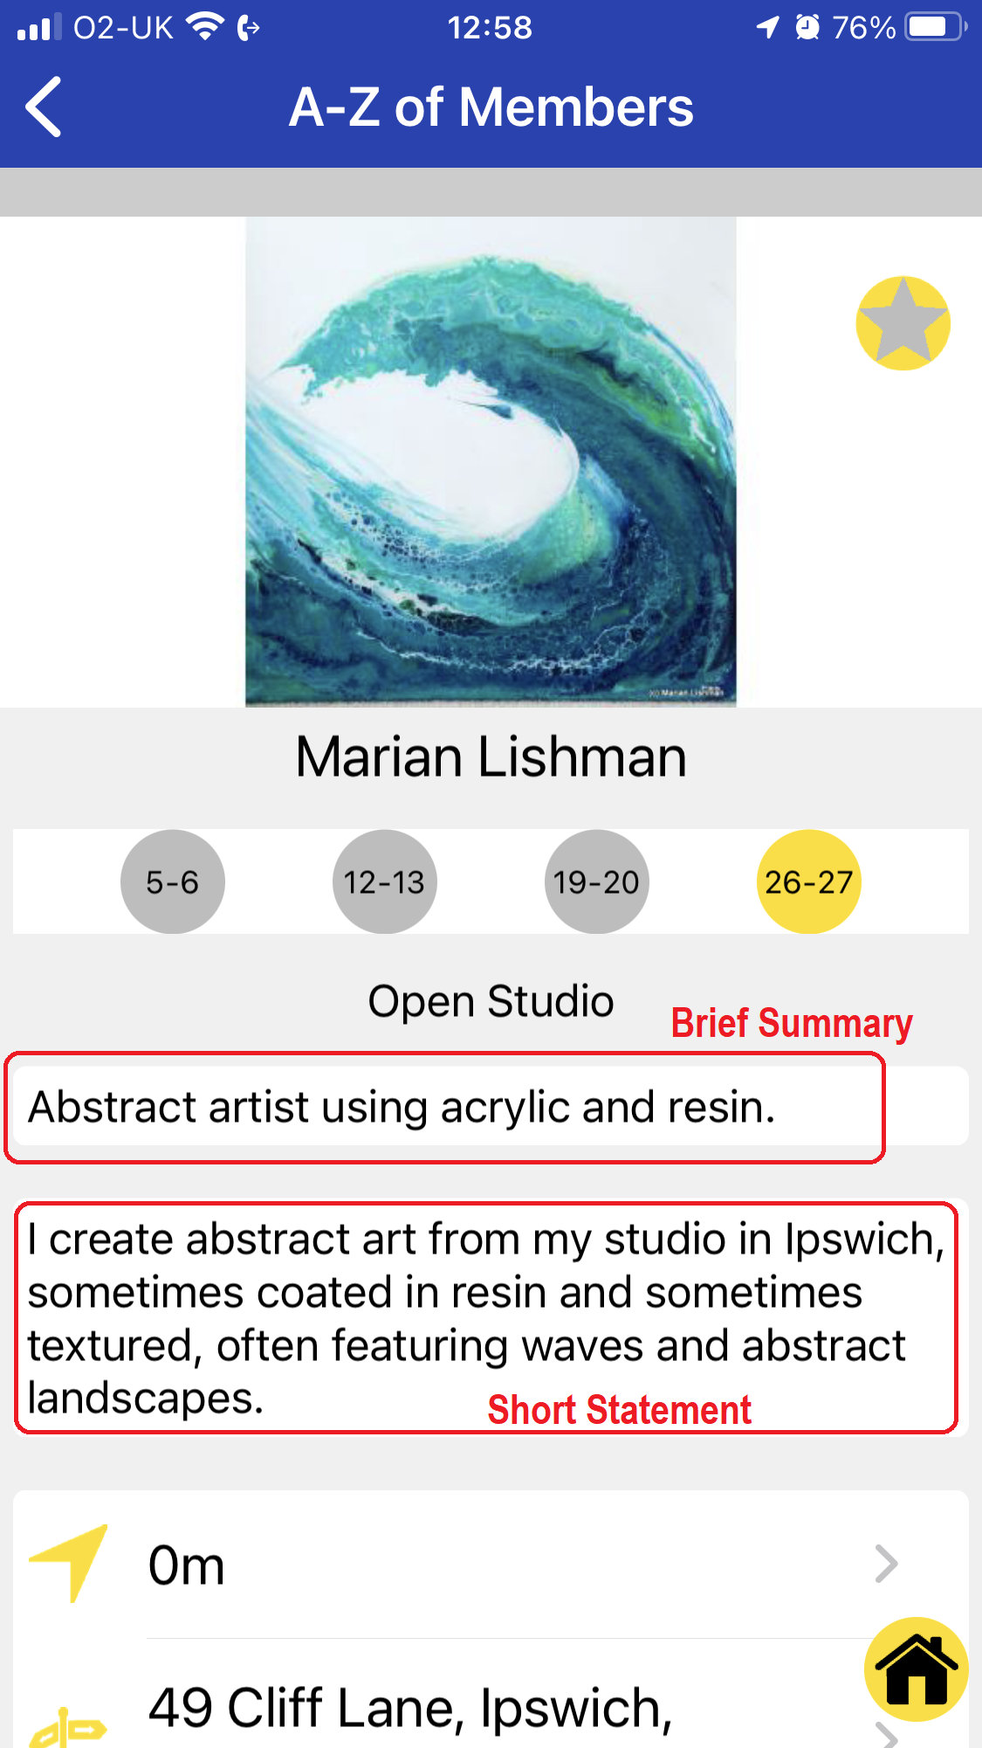
See above for where the Brief Summary and Short Statement are shown on the App (for new members you can download the 2021 App by searching for Suffolk Open Studios in your App store).

The end of page 2 looks like this:
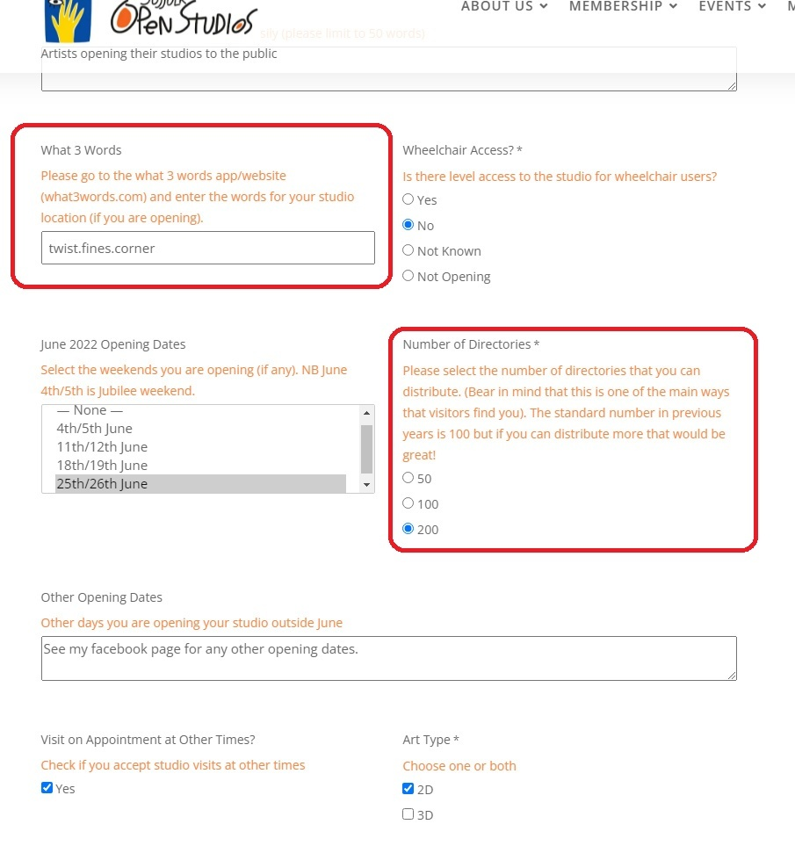
The main new fields here are what3words and number of directories. Last year we used latitude and longitude for the studio locations, but this led to quite a lot of errors where we didn’t have the correct coordinates. So this year we need you to find your what3words address via their website – www.what3words.com – please find your studio location and enter the 3 words with a full stop in between, into the field.
We are also asking how many directories that you think you will need this year, after feedback from last year. We encourage you to request as many as you can distribute as the success of Open Studios does in some way depend on people picking up directories. We have a list of places that they can be left if you need an guidance and we will also be offering to post directories to people for just the P&P cost if they cannot find one.

when you click on “NEXT” it will take you to the 3rd page with your images.
You can add new images if you have space (don’t forget to keep within the parameters of the image sizes before trying to load an image). Images must be less than 1Mb AND be less than 1500 pixels wide and high. Please check images before trying to upload them.
You can resize images using an online tool if you do not have a program that will do it, for example this website:
https://resizeimage.net/
If you already have 10 images and want to change some, you can find the delete button when you hover over an image.
Only when you click on ‘Save Changes’ will you save all of the data that you have entered on all 3 pages.
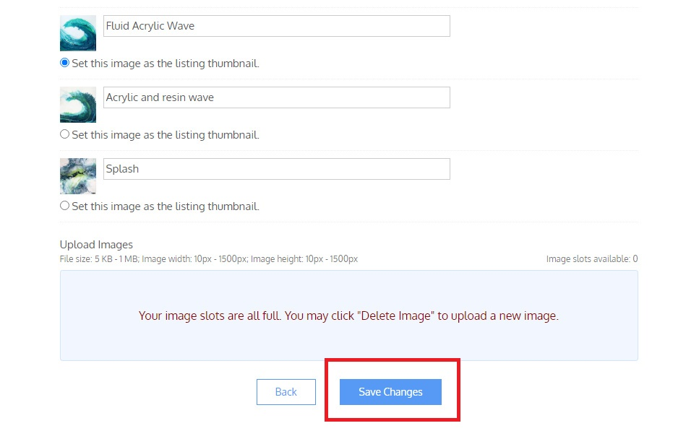

Hub/Studio Combinations

If you are opening at both your studio and a hub:
If you are opening at both then please just include your studio details and address on your own profile (plus dates you are opening at your studio) and select ‘Open Studio’ under the ‘Open Category’ field. Hub details will be added separately.

Hub Only
If you are only opening at a hub, for the time being please select ‘Non-Opening member’ from Open Category. Only enter a studio address if you are open for appointments or open at other times of the year at your own studio.

Non-Opening Members
If you are not opening or do not have a studio, then it is up to you if you show an address on your profile or not. We do need to capture your postcode though to know where our members are in terms of distributing leaflets etc.

